
Health Promotion Department
Brief Guide to Khat

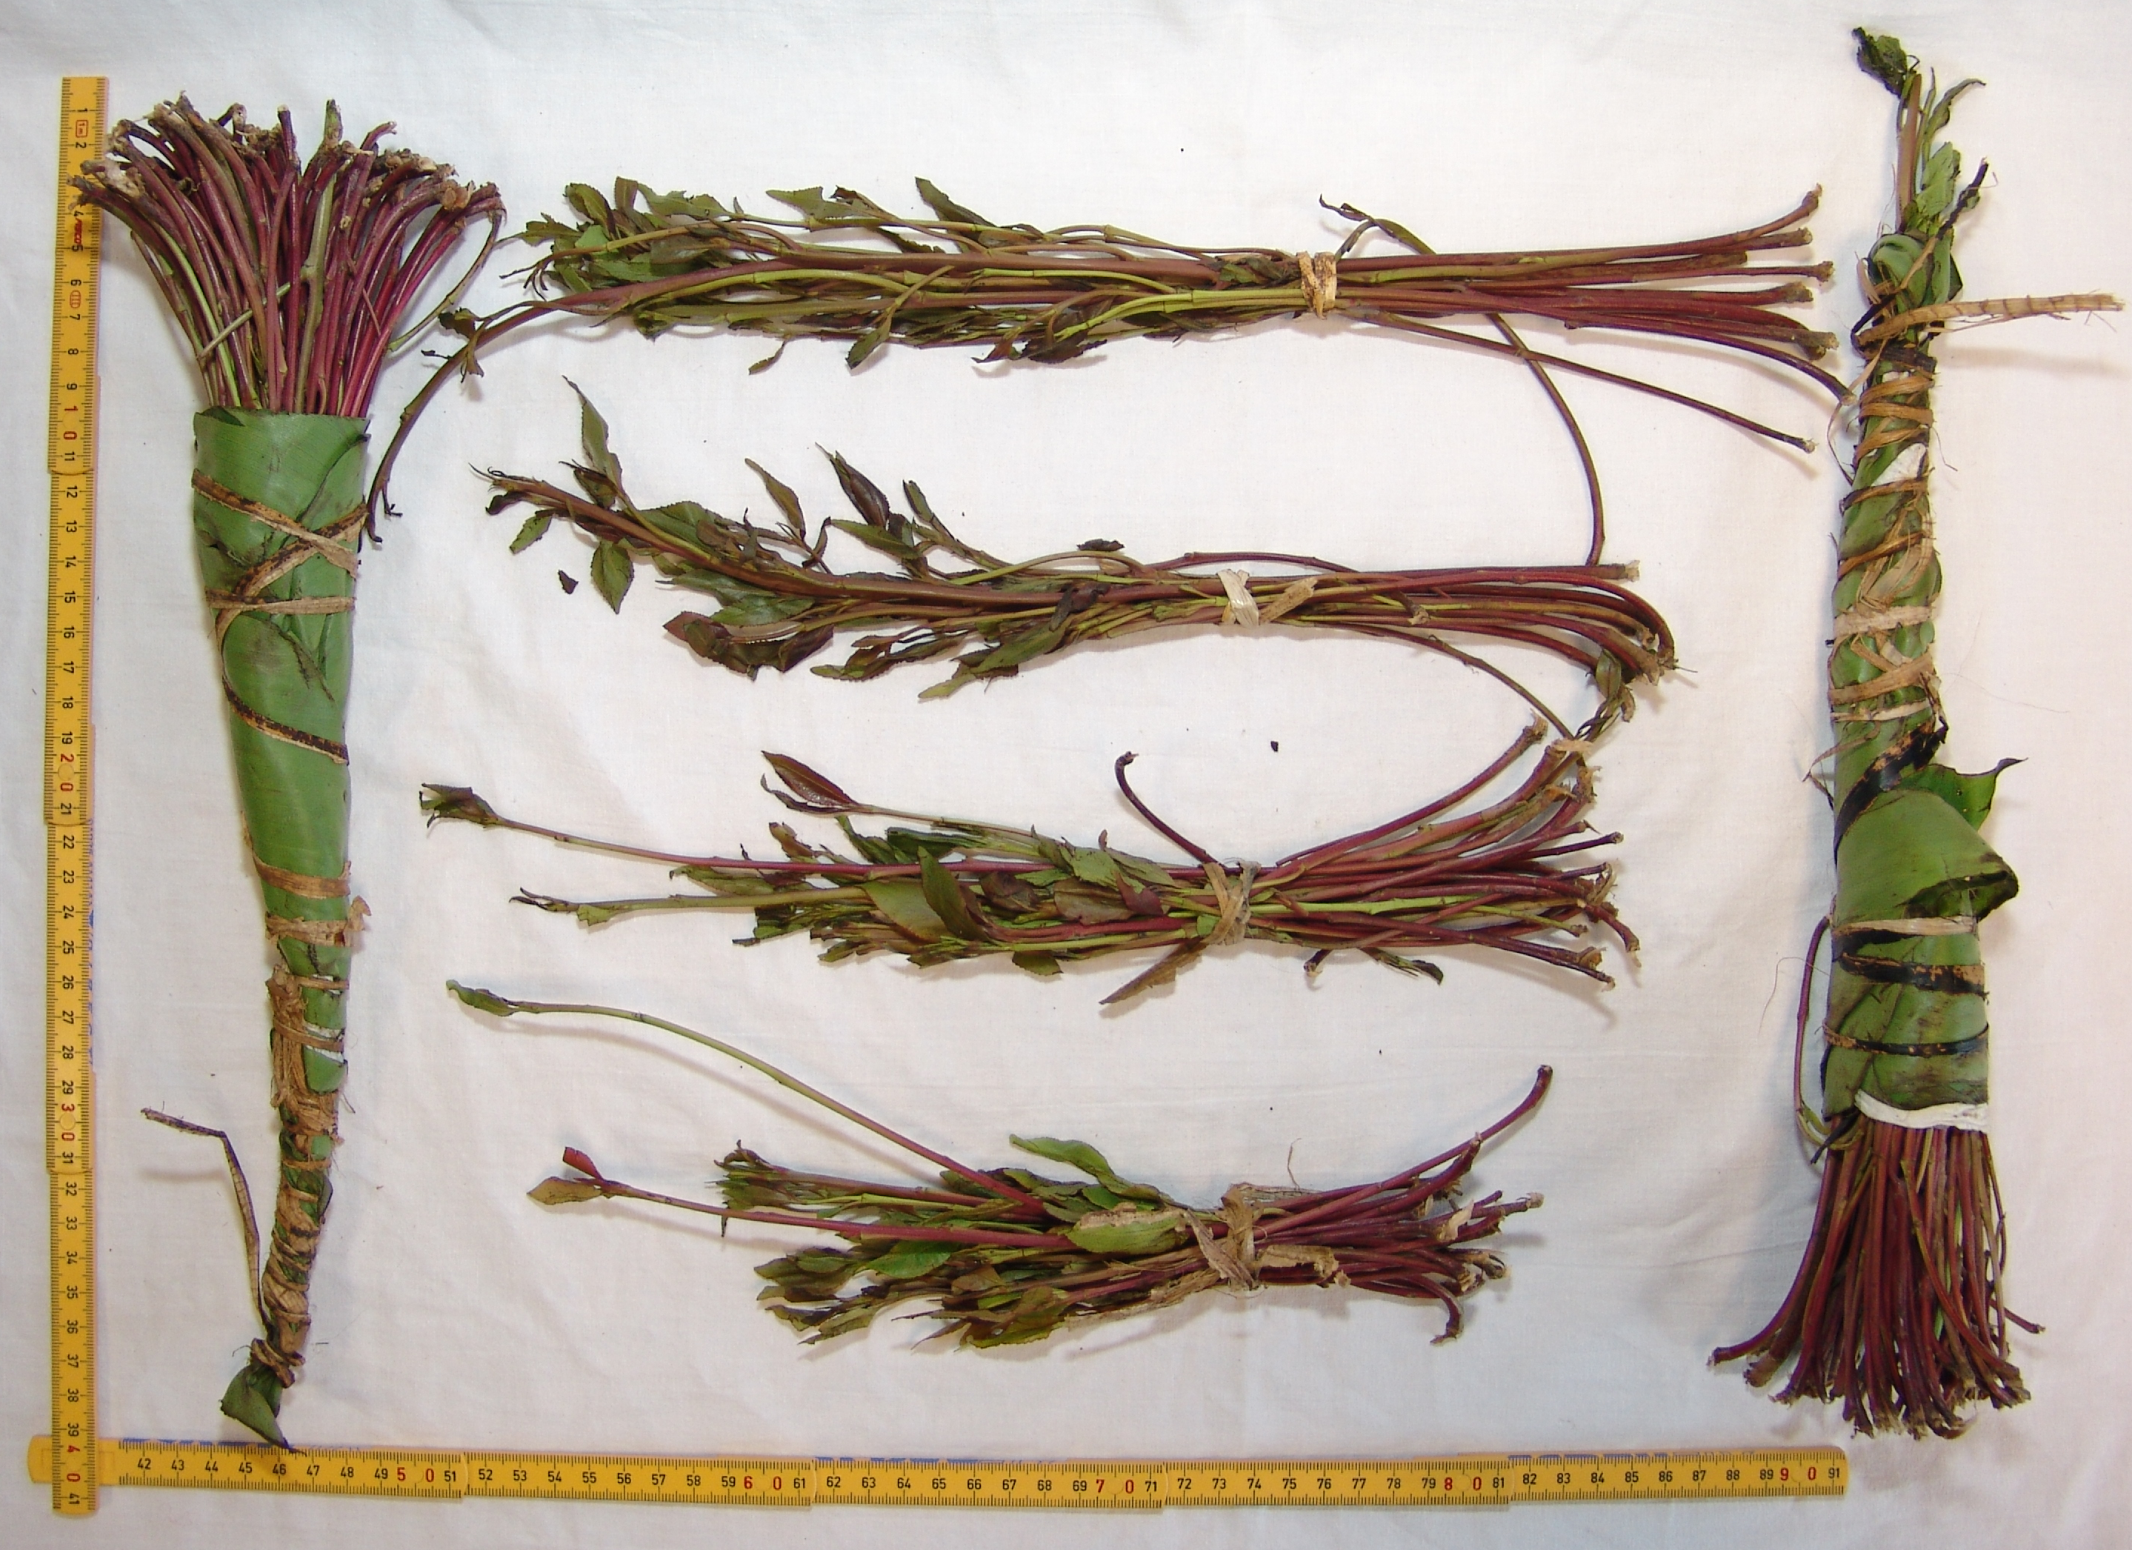
Photograph of Khat purchased in Wembley, September 2006.

Showing three bunches (approx £4 each) with one bunch unrolled to show the 4 separate bunches contained within the main wrap. The larger leaf wrap protects the delicate leaves and the tops of the stalks (which may also be chewed) of the plant.
(Yellow scale reads 40cm by 50cm)

Khat leaves are chewed before being “parked” between the gum and lip to allow the juices to be released, this process is a learned technique and, as with many other routes of taking drugs, requires practice. This process and the (at least) 20 minute delay before the stimulant effect on the brain “kicks in” has probably accounted for the low use of khat in communities not from the Horn of Africa or the Arabian Peninsula.

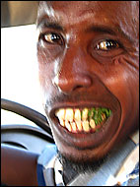

In the UK, Khat is legal to possess, supply and import. This is not the case in much f Europe and the United States of America. In December 2005, following advice from the “Advisory Council on the Misuse of Drugs” the decision was taken to maintain the legal status of Khat in the UK.

Approximately 5-7 Tonnes of Khat arrives in the UK every day, (much of which is in transit to other countries), The majority being flown in from Kenya (Khat grows well in the mountains alongside coffee) Khat does not grow in Somalia, (Some internet sites report growing Khat at home as not impossible but certainly not as easy as cannabis!)

Khat is chewed as fresh as possible as the stimulant effect will not be achieved after 4 days from being cut.

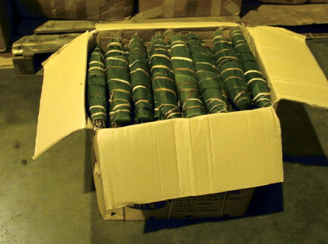

For More Information Visit
www.drugs.gov.uk/publication-search/acmd/khat-report-2005/
www.talktofrank.com www.drugscope.org.uk

© HPD, Brent tPCT – November 2006 (020 8795 7438)

